Project Design Phase-II Technology Stack (Architecture & Stack)

Date Team ID
Project Name Maximum Marks
3December 2025
SHOPEZ : E-commerce Application
4Marks

Technical Architecture:
A scalable, modular 3-tier architecture (Presentation → Business Logic → Data) with optional microservices for payments, search and order processing. The design supports fast product discovery, secure checkout, inventory consistency, and horizontal scaling for traffic spikes.

Table-1 : Components & Technologies:
Component Description Technology

User Interface
Customer storefront, product pages, cart, checkout, admin dashboard
HTML, CSS, JavaScript, React.js

Application Logic – Customer User registration, login, product search, add-to-
cart, wishlist, checkout, order tracking.
Node.js, Express.js

Application Logic – Admin

Application Logic – Payment
Product management, category management, stock updates, order management, user management.

Secure payment processing, order confirmation, invoice generation.

React js, Node js

Node.js, Express.js

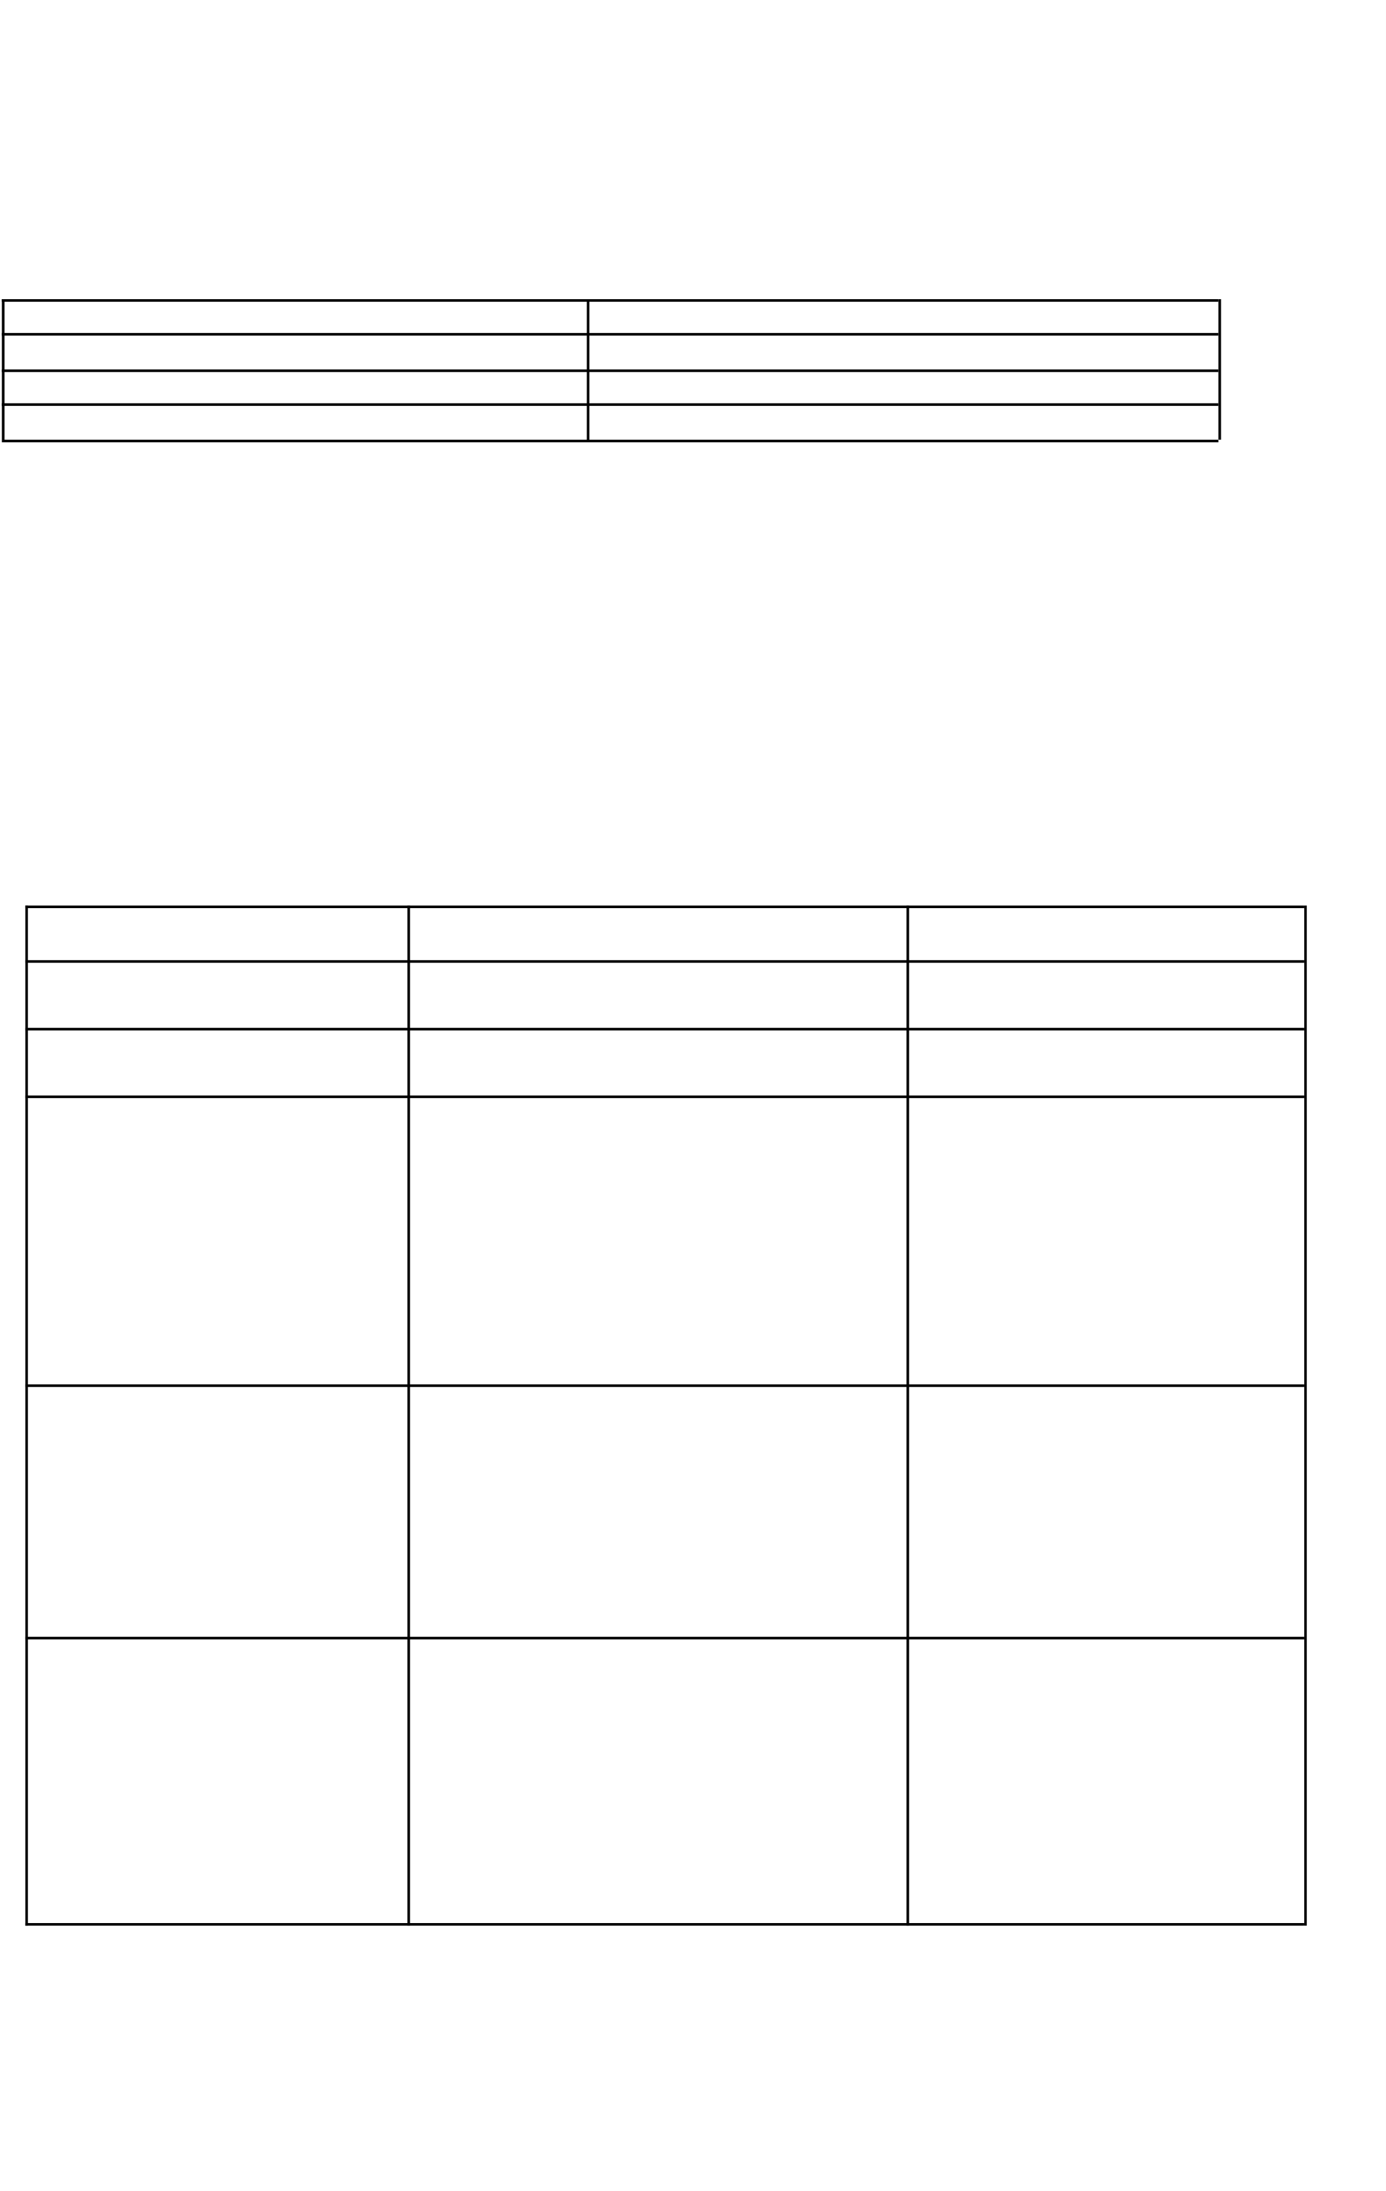
Database
Stores users, products, categories, orders, inventory, payments.
MongoDB

Table-2: Application Characteristics:
Characteristics Description Technology

Open-Source Frameworks Scalable Architecture High Performance
Secure Authentication

Uses modern, open-source frontend & backend tools for faster development and clean UI.
Clean 3-tier architecture with RESTful API communication suitable for growing product and user base.
Fast product loading, optimized API
responses, search efficiency.
Role-based login for Customer, Admin, and Seller with encryption.

React.js, Node.js, CSS MVC
React.js + Express.js JWT, Bcrypt

Flexible Data Handling
NoSQL database ensures scalability and fast queries
MongoDB

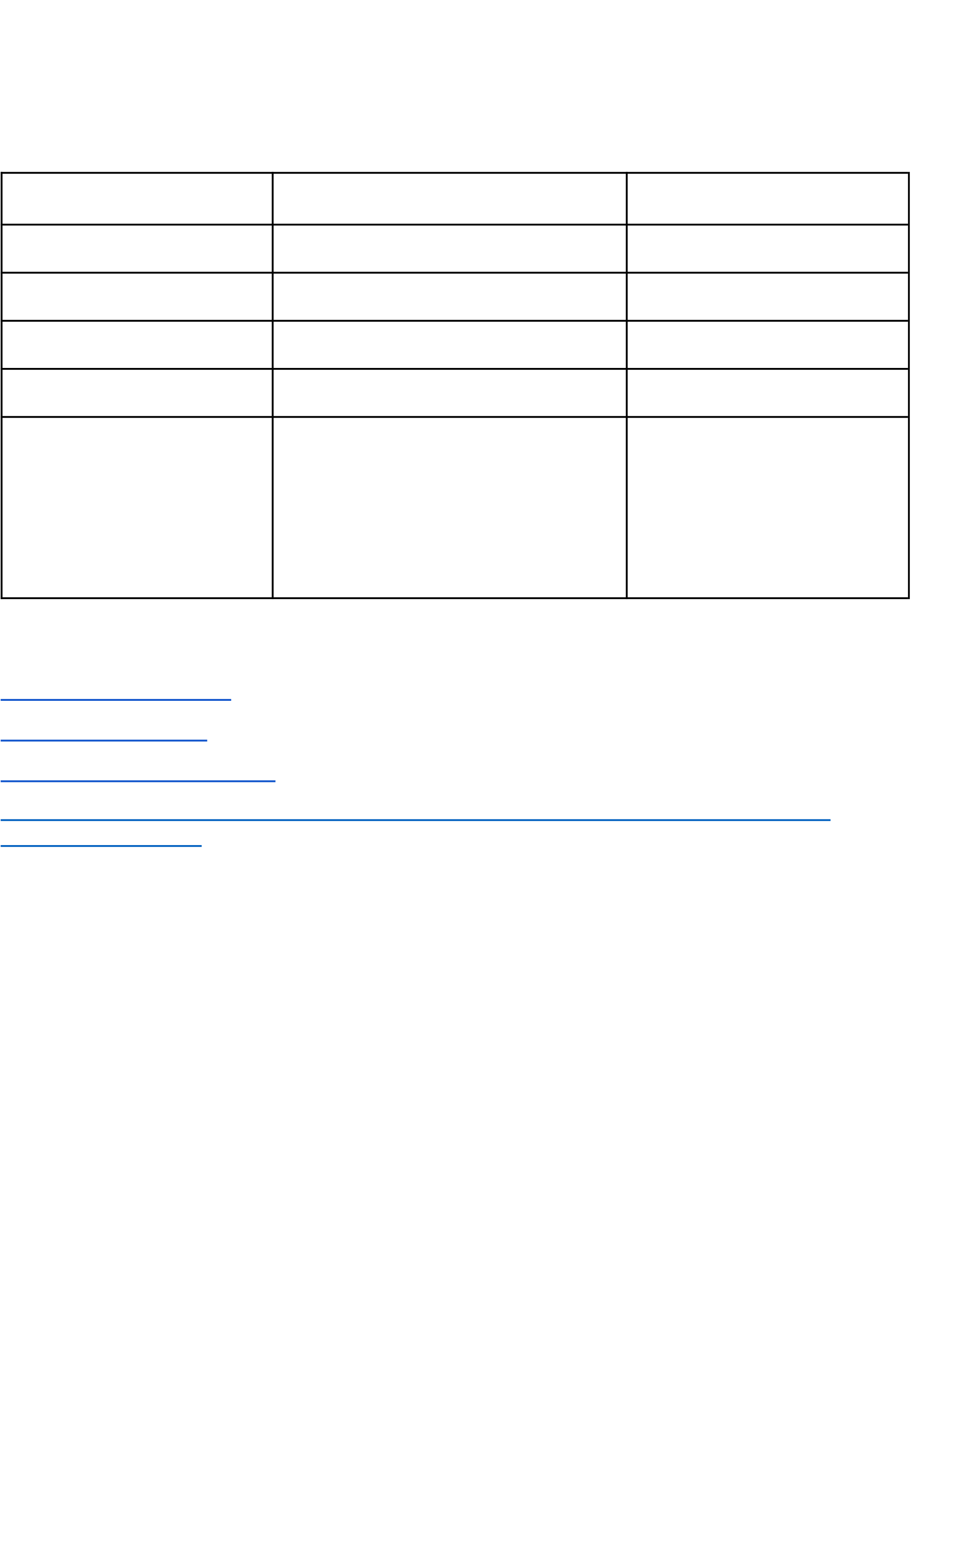

References:
React.js Documentation Node js Best Practice
JSON Web Server Referance
https://medium.com/the-internal-startup/how-to-draw-useful-technical-architecture-dia grams-2d20c9fda90d

